**PowerSchoolPM Management System**

**Proposal for**

*Your School*



“Any time there is a change, there is opportunity.

So it is paramount that an organization gets energized rather than paralyzed” -Jack Welch, General Electric

**Contact**

Nde Yanick Che

Gnoitik Guegang Vanes Loic

Ewang Clarkson Yves

Email: yanicknde@gmailcom

Mobile: +237675669236

**©May 2019**

# Statement of Confidentiality

All information contained in this document is provided in confidence and should be treated as such by all parties. It shall not be used for any other purpose, and shall not be published or disclosed wholly or in part to any other party without the express written permission of **TechEco limited**, and shall be held in safe custody. These obligations shall not apply to information that is in the public domain, held on the Internet, or becomes known legitimately from some external source. All intellectual property rights of products or services provided by **TechEco limited** shall remain vested in **TechEco limited.**

This document, its contents and attachments are subject to contract.

All Registered Trademarks referred to are herewith acknowledged.

TABLE OF CONTENTS

Statement of Confidentiality 2

1.0 Introduction 1

1.1 Executive Summary – The PowerSchoolPM Concept ($PowerSchoolPM$) 1

1.2 Our Proposal 2

1.2.1 Invitation to you 2

1.2.2 Proposition of the PowerSchoolPM Package 3

2.0 Our Solution 5

2.1 eLearning Content 5

2.2 ICT Resource Center 6

2.3 Test and Exam Results Management 7

2.3.1 Overview 7

2.3.2 Features 7

2.4 PromptPayPM 12

2.4.1 Overview 12

2.4.2 Features 12

2.5 Student, Parent/Guardian and Staff Records Management 12

2.5.1 Overview 12

2.5.2 Features 13

2.6 Payroll 13

2.6.1 Overview 13

2.6.2 Features 13

2.7 IMessengerPM 14

2.7.1 Overview 14

2.7.2 Features 14

2.8 Website and Others 15

2.8.1 Website 15

2.8.2 Others 15

3.0 The Options 16

4.0 Appendix: About TechEco Limited 17

4.1 Profile of Some TechEco Limited Key Personnel 17

4.2 What we have done in the past 18

# Introduction

The importance of information technology (IT) in education, whether it is used to support teaching and learning, or to develop student IT capability, or to support educational management, is now recognized throughout the world.

## Executive Summary – The PowerSchoolPM Concept (${PowerSchool}^{PM}$)

In our world today information technology is fast influencing how business is done and the ease with which one can do it. Transactions are now carried out across boundaries without any need for contact.

Nevertheless, it is still a sore point to see how many businesses refuse to take advantage of this emerging trend in information technology. Furthermore, a need to catch up with the rest of the world in information technology means providing or utilizing an educational curriculum that leverages on information technology.

A curriculum that leverages on information technology such as the Blended Learning Curriculum is the perfect fit for this purpose. The Blended Learning Curriculum combines normal day to day classroom teaching with real world computer mediated or assisted learning (e-Learning) to foster an effective teaching and learning process. It does not aim to discard your current curriculum but instead enhance it by providing an improved learning experience.

The Blended Learning Curriculum recognizes that certain concepts in daily classroom learning can be difficult to pass across especially when it involves abstract concepts as observed in various subjects been taught sciences and mathematics, so it utilizes e-Learning resources to fill up this learning gap thereby creating an effective teaching-learning process for the teacher and superb learning experience for the learner.

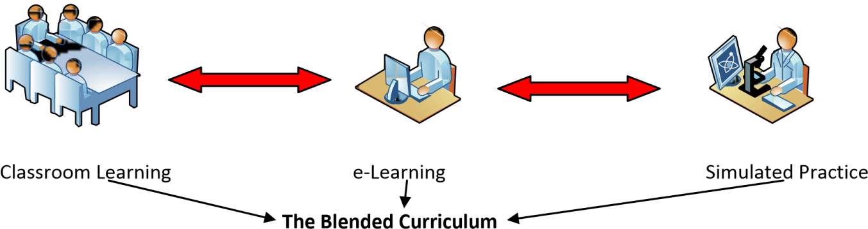

Having an e-Learning assisted or aided curriculum is wonderful but other aspects of a school, such as student records, school fees payment, performance notification and a host of other school processes are still being done manually by the school. Thus, for any school that wants to compete favourably in the future automating all these processes and more will be highest on their priority list.

The Blended Learning Curriculum and School automation system is introduced to your school as PowerSchoolPM. PowerSchoolpm is a complete package meant to take care of your schools needs from aiding in smooth school administration to effective learning.

PowerSchoolPM is a pioneering effort of TechEco which is known for excellence and commitment to deliver unique and world class solutions. PowerSchoolPM is aimed at automating the entire school process coupled with providing a sound information technology curriculum which is delivered by qualified and experienced teachers that have been trained to suit the learning needs of students’ right from Kindergarten through Junior Primary through to Senior Secondary.

The objectives of the PowerSchoolPM program will mainly be to:

* Provide state of the art IT Resource Center for Schools.
* Provide eLearning opportunities for the child.
* Provide a world class integrated IT curriculum and learning environment.
* Store, Retrieve, Update and Create Reports on any student at the click of a button.
* Provide a student performance notification engine.
* Provide a test/ exams results management system.
* Provide an engine that allows the school maintain their school account.
* Provide a payroll management system.
* Provide a website for the school.

## Our Proposal

### Invitation to you

To create an Integrated Learning Environment for your school we invite you to take advantage of this opportunity and make your school a leader in Information Technology and Information Technology Education for your students and staff.

### Proposition of the PowerSchoolPM Package

PowerSchoolPM is a complete Information Technology package that covers all aspects of the school as highlighted below

* ***e-Learning*** – E-learning which is essentially the computer and network-enabled transfer of skills and knowledge with applications and processes which include Web-based learning, computer based learning, virtual classroom opportunities and digital collaboration will be provided for your school. Content will also be deliver via the Internet, intranet/extranet, audio or video tape and CD-ROM. It can be self-paced or teacher-led and includes media in the form of text, image, animation, streaming video and audio.
* ***Resource Centre*** – We understand that the cost of putting together a state of the art IT resource center is quite expensive so we will provide the resource center at a point provided within the school for no initial capital. The Resource Center will be complete with projectors, internet facilities and e-learning capabilities.
* ***Test and Exam Results Management*** – This area will also be automated to allow automatic generation of continuous assessment results/ end of term report cards, transcripts, academic summary of a student or of the school at a glance and a lot of other academic reports as needed by the school from time to time.
* ***PromptPay™*** – We will provide a payment solution that allows your schools have an account with any bank and the parent/ guardian can still pay into this account via several services including mobile money. These payments reflect in your account real-time with receipt generation at that point of payment or by the school. Because we also know that you want to monitor your account instant notification and daily end-of-day summary report is also available for you.
* ***Student/Parent/Staff Record*** – For ease of storage and retrieval student details are mostly divided into three i.e. Student and Parent/ Guardian Details, Academic History and Payment History. All this details are stored in different files and a request for any of these details will mean a lookup of which files contain what and where to find such files.

Our Students Record solution allows you access to all these details together at the touch of a button. Other features of this Student Records software are generation of Reports which include any statistics on students, academics, payment history, general school academic performance etc

*Manual Students Record Retrieval*

*Computerized one touch access to student details*



* ***Payroll*** – The payroll software manages all aspect of administrative duties in staff payroll including computing salaries and remunerations on a wide variety of computations. This payroll software allows you add and remove staff, automatically compute benefits, control contract staff payments and more.
* ***iMessenger™*** – Notifying a parent/guardian periodically of the performance of his/her wards will be a welcome facility that any school can provide for parents/guardians as this saves them from the trips that they otherwise have to make to the school at a time that is only justified because of the love the parent has for the child.

With our Notification engine the school can notify any number of Parent/Guardian for any reasons at all which will include academic performance, school programmes, reminders etc

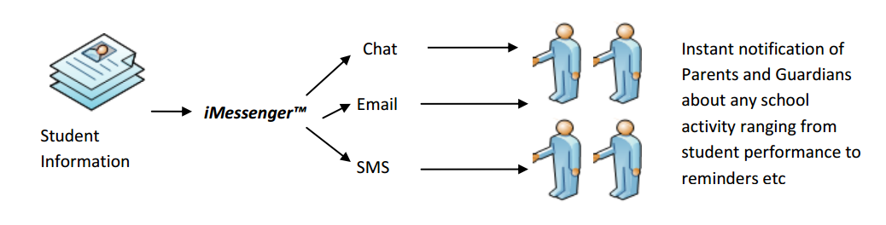

* ***Website*** – To make your school easily available to the entire world, we will build a website for your school and if your schools’ website already exists we will assist with upgrading it so that information about the school can be easily disseminated.

# Our Solution

The following is a list of our solution bundled together in the PowerSchoolPM package.

* eLearning
* ICT Resource Centre
* Test and Exam Results Management
* PromptPayPM
* Student/Parent and Guardian/Staff Records Management
* Payroll
* iMessengerPM
* Website and Others

We understand that your school might require the solutions separately so we allow picking of some of the solutions based on the needs of the school. All modules are built independently off one another.

To give a better understanding of what each of the solutions offer, we present an overview and feature of each of the solutions along with screenshots of some of the solutions.

## eLearning Content

E-learning is a revolutionized studying system put into place by Engineers of Tech-Echo which aims at easing the understanding of various subjects in secondary schools.

This is done with the help of a computer lab. The concept of digital learning here involves having some video lectures being projected either on a projector or on desktop machines. This will enhance and ease the understanding of the subject matter. For instance, if there is to be a lecture on volcano and tectonic movements, a small video can be registered about this phenomenon explaining briefly and well these processes. In this way the student understands better what is going on and keeps it in mind for long. Resources can be made available either by the teachers or by engineers from Tech-Echo under approval of teachers.

## ICT Resource Center

We understand that building a state of the art Resource Centre might be an expensive project to undertake, so we will provide a Resource Centre that comes complete with brand new computer systems, projectors, internet facilities and that is eLearning ready. This Resource Centre will be built such that its uses will not be limited to classroom teaching but can easily be adapted to a wide variety of purposes that include Parent-Teachers meeting, School programmes and a host of other activities.

The following picture shows a typical view of our Resource Center

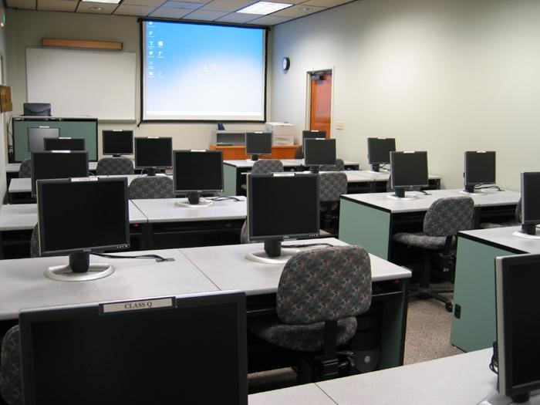

## Test and Exam Results Management

### Overview

Managing the sequential/termly results of students has never been easier with this module that only requires that you enter the subject’s marks of each students and it generates all the reports that you could ever require including customized school mid-term and end to term results. Report cards booklets can be generated for students and results records can also be easily generated as well as academic history of the school which could then be used for statistical purposes or as required by the school.

### Features

The features of this module are as follows

* Capture of student results
* Configuration of standard test scores fully flexible
* Levels of privileges for managing result data to ensure authentic and credibility of source
* Generation of report cards, academic history of school and students etc
* Easily plugs into iMessengerPM for student performance reporting
* Logs of defined activities in the system for accountability and traceability of events.

Below are some interesting mock-up images of test/exam result management system.

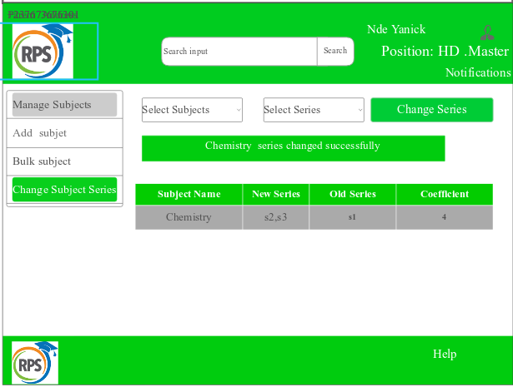

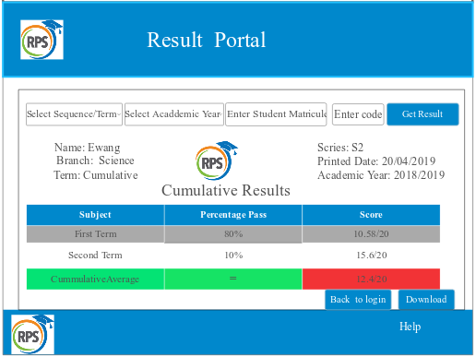

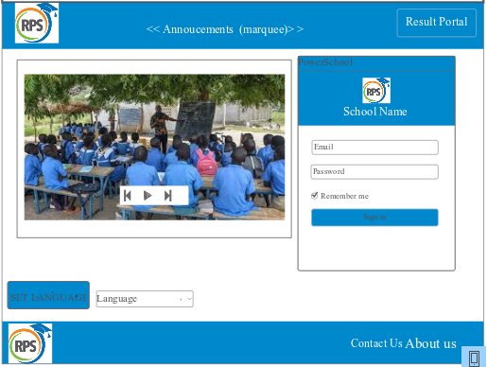

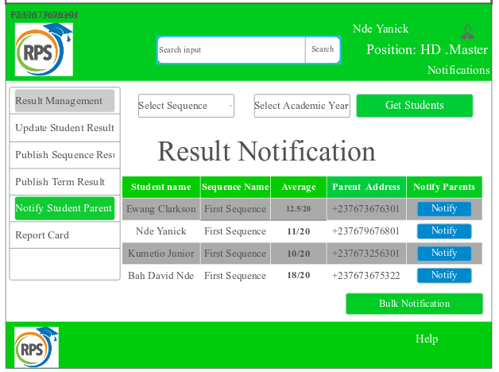

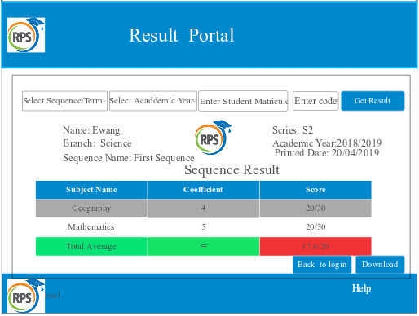

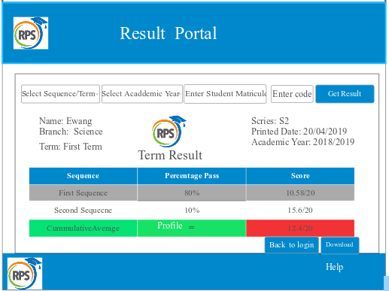

## PromptPayPM

### Overview

PromptPayPM is a payment solution that allows Parents and Guardians the luxury of making payments to the school via several payment methods; via mobile money accounts, VISA or Master cards, from banks and micro finance institutions. We redirect all payments to the school main account and ensure that the school receives exactly the stated amount for the transaction.

Notifications on all payments will be sent to the school as well as an end of the day summary of payments. Another super feature of this solution is its ability to generate receipts and invoices at the point of payments or by the school. These invoices and receipts are customized for the school.

### Features

The features of PromptPayPM are stated as follows

* Payments could be made from any bank, mobile money accounts, Master and VISA cards and all payments are funnel to a single account maintained by the school.
* End of day/monthly/yearly summary of payments
* Notification of payments
* Generation of reports to view all payments and detect defaulters

## Student, Parent/Guardian and Staff Records Management

### Overview

The Student, Parent/Guardian and Staff Records Management module consist of components that allow the schools manage the details of Students, Parent and Staff. This module allows a one click access to student information as well as allowing different kind of search based on different criteria to be carried out on students’ details that have already been captured and stored.

### Features

The features offered by this module is listed as follows

* Creation or entry/ editing/deletion of student bio data by defined privileges of user accounts (administrations accounts)
* Capture of information of Student, Staff and Parents/Guardians
* Generation of various statistics report, student/staff related data.
* One click search of information on any of them

The following are screenshots of this module

………………………………………………………………………………………………………………………………………

## Payroll

### Overview

With our flexible and cost-effective Payroll management system in-house payroll management has been easier. This comprehensive, easy-to-use solution includes all the payroll functionality needed by midsized and larger organizations to process payroll accurately and quickly, every time. The robust functionality of Payroll makes it easy to produce ***pay slips*** on demand, run trial payrolls, and make last minute changes with no hassle. It’s easy to meet the needs of your unique organization with flexible features, including unlimited earnings, taxes, deduction types, multiple user-defined pay groups, and customizable events.

### Features

The features of our Payroll module includes but not limited to

* Payroll allows you to create unlimited custom reports to meet the unique needs of your institution.
* You can enter data for multiple employees to accommodate work situations not based on the standard salary structure. And then generate payroll for each of them or all of them.
* Allows user to create multiple salary structures.
* Export all report data to external file.

## IMessengerPM

### Overview

This module was originally designed to allow the notification of Parents/Guardians about student performance in school activities but it can still be used to send reminders, notice of school activities and a host of other notifications.

This module comfortably plugs in to the other modules which need information to be sent out to anybody.

### Features

The features are as follows

✓ Ability to send messages in three channels i.e. SMS, Email and Chat

✓ Ease of plug-in to other modules.

## Website and Others

### Website

We will build a website for the school in case the school does not have any or assist in the upgrade of an existing website so as to be able to disseminate information and allow content to be provided for the users and visitors of the website.

### Others

From time to time in a school that has our presence, we will organize termly programmes such as Visits to places that enhances learning, IT weeks, Prize Giving days and a host of other programmes.

# The Options

We understand that your school may not require all these solutions as a single package so we offer you a chance to pick out of the solutions as they fit your need.

We allow payments for any combination of solutions in two different models

* Down payment (gross sale of the system) for any solution/combination of solutions or
* Payments made as technology fee by students over a period of time as agreed by both parties.

For more information, please do not hesitate to call us for a further presentation on all of the solutions or better still the solution which you have selected.

# Appendix: About TechEco Limited

TechEco Limited is a technology firm that specializes in software computing, electrical and electronics engineering services and other ICT computing services such as database management and application development, internet of things (IoT) and networking. TechEco provide high quality technology solutions with a concentrated focus on the educational, finance, medicine and defense sector.

TechEco strives to foster and grow empowered relationships with our clients. While small in size, the TechEco team collectively has over 8 years experience in computer/mobilesoftware application developments solutions, electrical installation, circuitry design, renewable energy, security system installation and networking. With TechEco office located at Buea Molyko, (known as the silicon mountain)with a branch center in Douala Caneroon,we have targeted local prime contracts, remote provision of services internationally, and provide domestic services to clients.

TechEco seeks long term contracts and projects with a focus on IT and electronics which are the two main departments (IT department and Electronic department). Rather than casting a broad net, TechEco targets three distinct government sectors: Education, Health and Finance. By specifically targeting these areas of interest, TechEco is the industry expert and can truly not only understand our customers’ needs but can identify solutions that are just as dynamic as the technologies and industries themselves. In turn we believe that TechEco customers will return time and time again for additional projects and long term contracts. In addition, the company plans to ultimately become a prime Tech firm and at that time will also hire a full-time RFP (Request for Proposal) writer to win the contracts.

## Profile of Some TechEco Limited Key Personnel

**NDE YANICK CHE**

#### Academic Qualifications

Bachelor of Engineering, Computer Engineering, First Class Honors, University of Buea, Buea Cameroon

#### Personal Details

Nde is the Co-Founder of TechEco Limited.

#### Experience Summary

**Network Engineer at Camtel Bepanda Douala, Abeboh Tech Buea**:Networking technologies, VPN, MPLS, CISCO technologies and device configurations, part of the team for the installation of Aps at the Douala international airport for the CAF inspection committee.

**Developer at Skylabase Inc**: Java OOP program and mobile app development, python program (Django framework), Angular and React.

…………………………………………………………..

Please kindly input infos on your professional profile that might enhance or endorse our organization to show we are skilful.

## What we have done in the past

No better way to talk about our stability and the robust nature of our solutions than to tell you about a few projects that we have implemented in the past.

Please kindly input info’s on your personal projects accomplished here, let’s use it in the name of the organization.